**Project Description**

The project aims to make exercising/dancing fun with VR and Sensors. Body movements will be sensed with attached sensors (eg. vive tracker) and converted as input for the VR system. Users play the game by exercising. Appropriate virtual (in-game) rewards will be designed to motivate the players following the correct movements (dance or exercise movements). Accumulated reward points can be converted to physical items.

**Tentative Timetable**

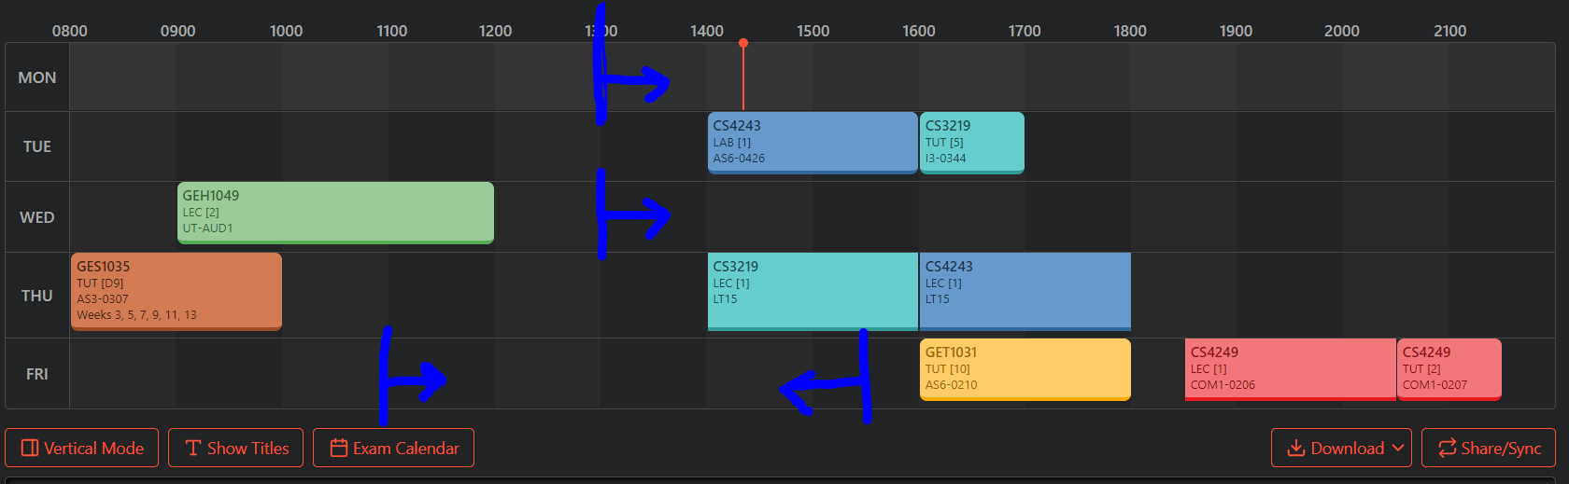

### Not Dodgeball VR the game 2020

**Core mechanics:**

* Two players (A and B)
* Goal for A is behind B and vice versa
* Goal follows rotation of player
* Game starts with 1 balls, the players try to score into their respective goals (which are behind the opponent)
* Points awarded for goals depends on the size of the ball < tentative
* Every ball that is scored causes 2 balls to spawn (TBC)
* The maximum number of balls allowed in the game is decided by the game host
* The duration of a match, as well as the number of matches to count as a game, are also decided by the host
* If a player catches a ball he/she can change the size of it
  + Or maybe the players spawn the balls themselves and hence can decide the size upon spawn?

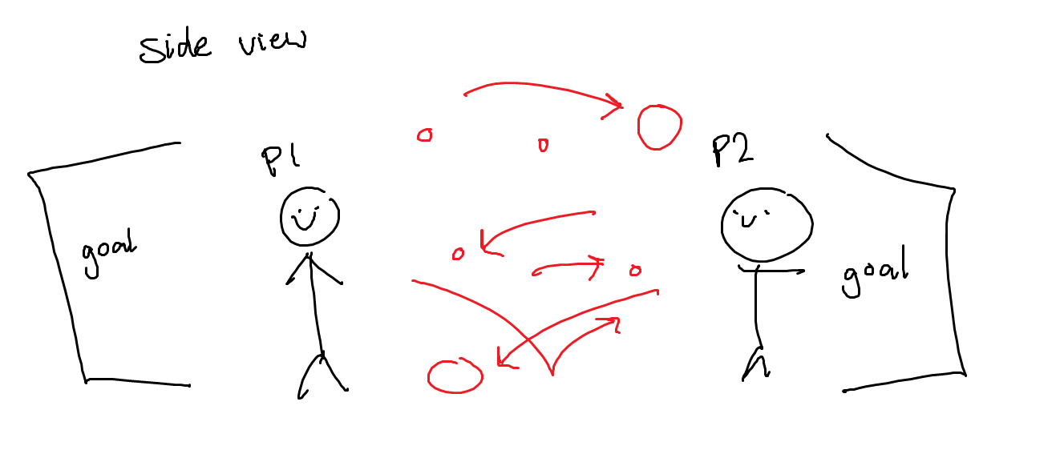

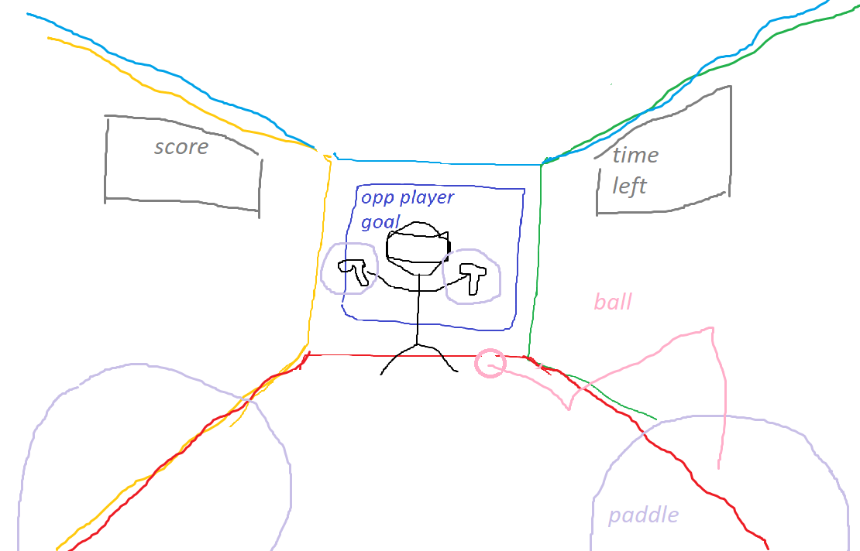

Viewpoint from a player

**Fitness involvement:**

* Requires a lot of movement. Kicking and smacking balls are allowed, hence it can be a full body workout

**Projected behavioural impact:**

* It is a game that would be a logistical nightmare to implement in real life due to the number of balls to keep track of, so it is safe to assume there is no viable substitute for this game
* With gimmicks such as daily rewards and in-game purchases implemented right, we can keep a significant number of players hooked on to the game and play it everyday

**Notes:**

* It would be desirable to have a single player mode. We can use pure random rotation and flailing about to create a simple bot, but we should eventually turn to AI
* Requires minimally a tracker on each foot for kicking and/or dodging
* Can either make both players have square colliders like they’re really fat or add another tracker to the pelvis for accurate dodging
* This is also hard to make on PC too so it’s very good for VR
* In case of the ball coming to a stop, the ball shod return to the players hand???, since ideally the ball never comes to a stop, like air-hockey style, but if it just bounces without any player input, after a while wouldn’t it come to a halt due to friction.
* Should we curve the edges of the walls where they intersect to make the bouncing less predictable humanly? Again, more like air hockey style.

This sem just make a simple playable game first, next sem then add the crazy shit

Also add marketing?

Need some learning value? Demonstration of new hardware? Pure game is ok but no A :( e.g. learn properties of diff materials (rubber vs beach ball vs rugby etc but by developing our own physics engine provided we can prove that existing one is not good enough)

Let players upload their own materials? Or at least customize existing ones

Customize walls and tools too

Do it for the KIDZ

Individual contributions eg one do sensing hardware or smth

### Use machine learning to build our AI?